Computer Language Coding Concepts

Black Box
The concept of Black Box is also known as the concept of Public and Private. Private makes something only accessible inside the object. Public makes something accessible outside the object. That way, the inner workings of an object are hidden away and you only see the input and output.

The code generator version of the the computer language (version 0.9) simply borrowed the public and private concept of the target programming language for which code was generated. The generic module version of the new computer language (version 2.0) did not have any black boxing yet at all. The black box implementation of the version to come is to be worked out in this documentation folder.

The documentation folder currently contains only one document, mainly consisting of a throw-together of ideas, yet to be turned into good documentation. Also, a lot of the material came out of an old document about the diagram notation.

The idea for the future is that user access control and black boxing access control will become a single concept of ‘what has access to what’, but that will not immediately be done at first. A simpler black box method is worked out first: one much like what you see in contemporary programming languages. However, this method must be adapted to the new computer language, because the new computer language has a different view on objects and commands. Which commands get access to the private contents of which objects is less obvious, because a command is not part of a specific object or class. In fact, no command gets access to the private contents of an object, unless that command is a friend of the object. This creates a tighter bond between the command and the object. Another thing, that has to be thought through, is that commands are no more than objects, so how does black boxing work when commands and objects are the same thing? This all is to be worked out in the future in this documentation folder.

Author & Copyright: Jan-Joost van Zon Date: June 26, 2009 – July 18, 2009 Location: Oosterhout, The Netherlands Status: Under Construction

Ideas Organized

Main Issues

The Black Box Principle
Most computer programming languages make it possible to apply the black box principle. Using the black box principle allows you to hide and protect the inner workings of an object. You only get to see some properties, parameters and a selection of commands through which you can control the object while the inner workings are hidden away and protected.

There are two key purposes of the black box principle: data protection and complexity hiding.

Complexity hiding can also be called abstraction: what really happens gets an abstract representation.

Private & Public
The inner workings of an object or command are its private members. You only get to work with an object or command’s public members.

So the privates of an object are protected and hidden away, while the public contents can freely be used.

Friends
There is no point to private content if it is not used by anything. Even though private contents are protected, something needs to access and protect that data.

An object’s public contents can be accessed by anything that has a reference to the object. Private contents can only be used by friends. Friends are objects that have access to the private contents of another object.

The object with private contents declares which other objects are its friends.
The friendship does not automatically go both ways: the befriended has access to the privates of the friend, but the friend does not have access to the privates of the befriended. For that you would have to establish a mutual friendship.

Friend Relations
A befriended object declares which object is its friend. The friend object needs to be able to access the befriended’s privates. Therefore the friend needs a reference back. So a friend connection requires a mutual relationship.

It is not like one class gets access to the privates of another class. It is more specific than that. A friendship is a relation between specific objects. A friendship between objects applies to only one specific relation. One object gets access to the privates of another object through one specific reference.

Friendship can also be applied to related lists instead of just related items.
An item or list in a specific relation is typed as friend.

Accessible & Inaccessible
Black boxing is based on two simple concepts: accessible and inaccessible. You can express those concepts as follows:

  Accessible |   Inaccessible

The concepts are not litterly used inside the language, but all the other black boxing concepts are based on it. You will not find accessible and inaccessible litterly notated anywhere, because the notation conflicts with the notation for Public, Private and Friend. But the used notation is based from these two simple concepts.

The notation of Accessible and Inaccessible can be used in abstract diagram expression, though, which does not have to be syntactically correct, but is only used to make a point.

Access Controlling System Aspects
Each aspect of a symbol can be separately access controlled. Those are aspects such as:

- Object
- Class
- Value

Each aspect’s Get and Set are separately access controlled, for instance:

- Object Get
- Object Set
- Class Get
- Class Set
- Value Get
- Value Set

So when Object Get is Public, you can reference the sub-object.
When Value Set is Public, you can assign a value to the object.
When Value Set is Private, you can not assign a value to the object except for Friend objects.

Only system procedures get access controllers. Objects do not get access controllers directly. Access to an object is controlled by access controlling the Object Get procedure. To control access to an object you are actually access controlling system commands.

There is not just one kind of Private or Public. There is a separate Private and Public for every Get and Set of every system aspect.

Summarized
System aspects of sub-objects are access controlled by their parent object.
You access control system aspects, making their Set or Get Private or Public.
A normal reference only offers access to the Public content of an object.
You can type an item or list in a specific relation as Friend.
When a Friend has a reference to an object, all its sub-objects are accessible, even when they are Private.
The full access that Friends get, applies to accessing the direct sub-objects, not deeper sub-objects.

Notation

Public & Private

Public Set / Access Connectors
The general notation of an access connector is as follows:

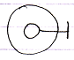

The sub-object is access controlled by the parent object. The line with the stick at the end is the access connector.

It is also the general notation of a Public access connector.
More specifically: it is a Public Set access connector, because it denotes, that you can make it point to something.

Public Get
The notation of the Public Get access connector is:

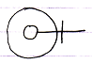

Because this denotes, that you can point to it.

Private Set
The general notation of Private is:



The cross expresses ‘inaccessible’ or better said ‘restricted’. Access is restricted to only a limited group of objects: the friends.

More specifically: it is a Private Set connector, because it denotes that making it point to something else is restricted.

Private Get
The notation of the Private Get access connector is:

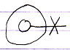

Because this denotes, that pointing to it is restricted.

Friend Declaration
This section covers friend declaration in several situations.

Friend Declaration, in a Unary Relation
The following is a unary relation:

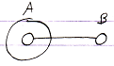

In the following picture object B is declared friend of object A:

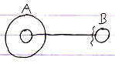

Object A can now access anything private of object B through the reference contained inside object A.

It is object B who declares itself Friend, so object B gives access to its private members.
But the friend declaration is part of A’s reference to B, because it makes the reference special, using the friend access symbol.

Friend Declaration, in a Dual Relation
The following picture expresses a dual relation:

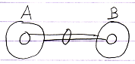

In the following picture B is declared friend of A:

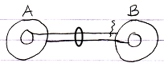

A can access everything of B, even the Private stuff. It does not go both ways: B can only access the Public contents of A.

Friend Declaration, Container is Friend
In the following picture, a related object is only displayed as contained inside another object:

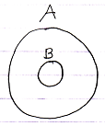

To declare A as friend of B you can use the following notation:

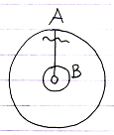

Now B can access everything of A.

Friend Declaration, the Contained is Friend
In the following picuture a related object is only displayed as the container of another object:

To declare B as friend of A you can use the following notation:

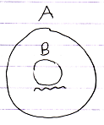

A can access anyting of B.

There is no line to place the friendship declaration on. The relation is implied by the fact that something is contained inside something else.

Mutual Friendship Referential Notation
Mutual friendship can be expressed as follows in a referential notation:

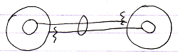

Mutual Friendship Containment Notation
Mutual friendship in a containment notation would look as follows:

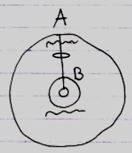

Different Notations of Private
Private access connectors get a different notation in different situations.

Private in a Definition
In a definition the private access connector is a cross:

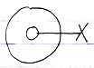

This is because access is restricted.

Private Set in definition:

Private Get in definition:

Private in a Friend Reference
Inside a friend reference, a Private member becomes accessible, so the access connector it is displayed using a wavy line:

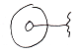

Which expresses accessible, but only to a select group of objects.

The following diagram expresses a member with Private Set accessible from within the befriended:

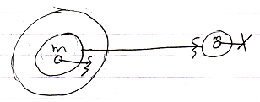

The circle on the right is the definition, so the its member is displayed with a private access connector there (a cross). The access connector within the Friend is different. It is drawn with a wavy line, expressing ‘access conditionally’. In that situation the Private access connector is also called a Friend access connector.

The following diagram expresses a member with Private Get accessible from within the befriended:

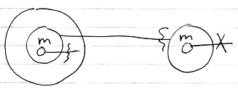

You can differentiate the Friend access connector from Friend declarations because an access connector has nothing at the end of its line.

Private in a Normal Reference
In normal references, private members are not shown at all.

The following diagram shows a member with Private Set not accessible or visible from in a normal object:

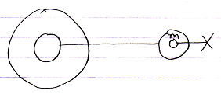

And that is where the complexity hiding kicks in. The circle on the right is still the definition, so it does show the Private member while the normal reference on the left does not show the Private members of its related object.

The following diagram shows a member with Private Get not accessible or visible from within a normal reference:

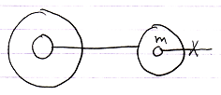

Friend Declarations in a Non-Definition
The points made in the section Difference Private Access Connectors are demonstrated here again in a different situation, where objects have external definitions. To summarize the rules:

- Privates visible in definitions
- Privates invisible in normal references
- Privates visible in friend references

In this section of the documentation it is demostrated how this looks if objects have an external class, as opposed to defining their own contents and behavior.

The main thing clarified here is: “when do you show privates and when do you not”. The same rules apply here as in traditional text code, but now they are demonstrated in a diagram.

In a Unary Relation

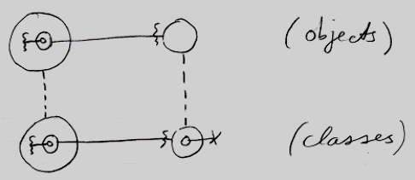

The classes show privates, but the objects do not, unless they are Friend.

The effect that you see, is that wavy access connectors stay there in the objects, while cross connectors disappear in the objects. So the main rule is: crosses disappear, wavy lines stay visible.

In a Dual Relation
The main point to the diagram below is that the classes show privates, but the objects do not, unless they are Friend. It shows the situation in case of a dual relation.

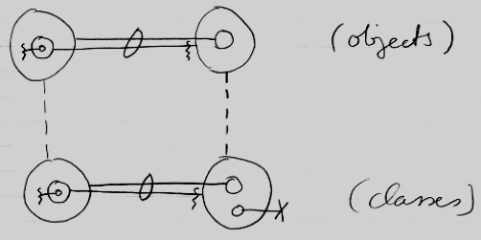

The effect that you see, is that wavy access connectors stay there in the objects, while cross connectors disappear in the objects.

Container is Friend
The main point to the diagram below is that the classes show privates, but the objects do not, unless they are Friend. It shows the situation where the container is Friend.

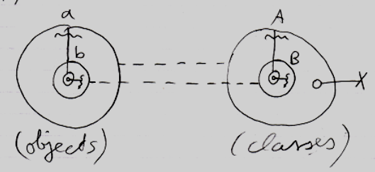

The effect that you see, is that wavy connectors stay there in the objects, while cross connectors disappear in the objects.

The Contained is Friend
The main point to the diagram below is that the classes show privates, but the objects do not, unless they are Friend. It shows the situation where the contained is Friend.

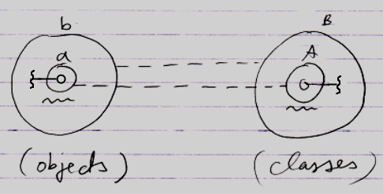

Here something different is going on in the notation. Earlier it was stated that: crosses disappear, wavy lines stay visible. But the picture above contains no crosses at all.

In the classes on the right, something unusual is going on.
The problem is, that A is both a definition and a reference at the same time.
A is:

- a definition

and also:

- B's (Friend) reference to A.

In a definition it should be a cross. In a Friend reference it should be a wavy line.
To express the member’s accessibility, the choice was made to display it with a wavy line and not with a cross.

This is simply a side-effect of the notation where the contained is Friend.

Connections
< Remembering, that the access connector stays visible has to be adressed in a single section and these explanations should not be bothered with that. >

An actual connection does not replace the access connector: an access connector is always displayed, because others can still connect to the object as well:

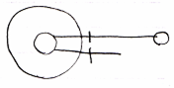

The line at the top is an actual connection.
The line at the bottom is the access conector.

Public Get Connection
A connection to an object, that required a Public Get access, looks like this:

The access connector stays visible, so that others can also connect to the object using Public Get.

Public Set Connection
A connection to an object, that required a Public Set access, looks like this:

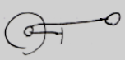

The access connector stays visible, so that others can also call Public Set and change the connection of the object.

Outward and Inward Connections
The connection displayed in the last picture does not have an access mark. Outward connections do not have access marks. This is not only because outward connections are more common, but also because an outward connection is more passive than an inward connection.

When a symbol is inward connected:

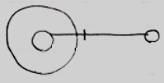

each consult of the symbol on the right, that connects inwards, results in a call to to the Get of the target symbol. So the connection is more active in that each consult of the source object requires a Get on the target object. Inward connections are also called Get connections.

When a symbol is outward connected:

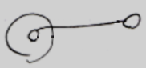

the symbol is directly connected to the target object. It stores the ID of the target object and refers to it directly, without executing a Get on each consult. The outward directed connection may have been established through acccess to a Friend Set command, but that call is history. The connection does not have to pass through to the insides of another object. Outward connections are called Set connections. However, the Set action is history and all that matters is the result, not how it was established.

Passing through to the inside of another object requires a the Get command of the target symbol to be executed.

This also conforms to the idea of automatic containment. In automatic containment, outward directed connections are automatically established: automatically drawn out in the diagram without an intervention of a programmmer. Inward directed connects were actively established by the programmer. They follow a qualification before getting to the final object. They are more active and display an access symbol and result in active Get’s taking place all the time.

Friend Connection
The general notation of a Friend connection is as follows:

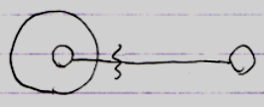

But remember that the connector always stays visible:

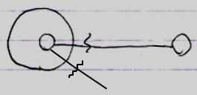

Friend Declaration, Connector and Connection
Here the difference is demonstrated between the notations of Friend declarations, Friend connectors and Friend connections. It will also become apparent how their notations disambiguate.

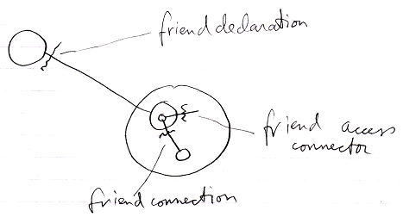

The friend declaration is always shown directly near the befriended (the situation at the top).
The friend access connector is always a loose end (the situation in the middle): one end of it is not connected yet. It is a placeholder for possible connections. A friend connection (the situation at the bottom) is connected at both ends. But the access symbol is placed in front the parent of the target symbol. This is because you always access an object through the parent symbol. The parent symbol can impose access restrictions onto its child objects.

If the friend connection would be an outward connection, no friend access mark would be displayed at all:

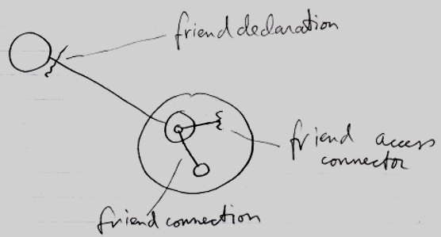

The friend connection shown there is not really a friend connection either. It is just a connection, an outward connection, a passive connection. What a releaf that a passive connection does not require an access symbol at all, or it would have conflicted with our friend declaration notation, which looks a bit like an outward connection with an access mark displayed in it, but it is not an access mark; it is a friend declaration.

Friend Get Connection
The picture below shows a Friend connection to Private Get:

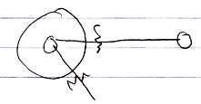

Friend Set Connection
The picture below shows a Friend connection, that required to Private Set access:

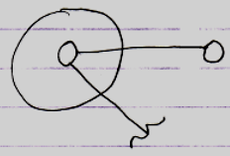

Accessing Other Aspects
The diagrams in the previous articles explained the concept of accessing Public or Private members. Those were all demonstrated using the Object aspect. But there are more aspects you can access, such as the Value aspect and the Class aspect. Those can also be made Public or Private.

The following sections lay out the workings and the notation of access controlling any of the system aspects. Connectors and connections of the following aspects are covered:

- Object
- Class
- Value
- Data
- Clone
- Execute
- Existance

Each aspect has its own unique behavior.

The Interface aspect is not covered here, because it is covered by the Interfaces article group.

Not everything about aspects is explained here. Aspects are explain inside the System Objects article group.

Object-Bound & Reference-Bound Aspects
When access controlling system aspects, it is important to understand that some aspects are bound to the object, while other aspects are bound to a mere reference to the object.

Object-bound aspects are access controlled by the object. The object also controls the reference-bound aspects of its sub-objects. Therefore reference-bound aspects can also be called sub-object-bound aspects.

The following aspects are object-bound:

- Value
- Execute
- Clone
- Data
- Class

The following aspects are reference-bound (or sub-object-bound) :

- Object
- Existance
- Class

The Class aspect is both an object-bound aspect as well as a reference-bound aspect.

Understanding that some aspects are object-bound is important, because it makes sure that object-bound aspects stay safe and not all of a sudden become accessible through another reference to the object.

So an object does not only control access to its sub-objects. It also controls access to its object-bound aspects.

Key Example: Value Get
If the Value aspect were reference-bound and made read-only by a reference and you could still Get the Object, you could assign the Object to another reference and write the Value there. Read-only protecting the Value aspect would be non-waterproof and more like a suggested access control, rather than real access control. By realizing that the Value aspect is object-bound, you can not make a read-only Value aspect all of a sudden writable through another reference.

Reference-related aspects only count for a single reference and not for the whole object, and can be freely overridden by another reference. Object-bound aspects count for all references and can not be overridden by another reference.

By binding some aspects to the object and some aspects to a reference, each aspect can be safely access controlled without any loop-holes through other references.

Another Example: Use As Class
Use As Class is basically an Object Get, access-controlled for the specific purpose of using the object as a class. By making Use As Class object-bound it is possible to design the system so that it indeed is not possible to use the object as the source in a class assignment. So things like Use As Class can also be made safe now they are object-bound. When Object Get is Public, Use As Class can still be Private.

Class both Object-Bound and Reference-Bound
The Class aspect applies to both objects and references, but differently. An object has a certain class, which is fixed upon creation of the object and throughout its lifetime. A reference also has a class, defining which class of object you can assign to the reference. The class of a reference can be manually changed. The class of an object can never be changed, unless you convert it, thus creating a new object.

The only two possible situations are that the class of a reference is not filled in at all or that the class of the reference is the same as the class of the object. Even though there are only two possible situations, objects and references still each need to separately store which classes they have.

Object-Bound Access Control
Object-bound access control is visible through each reference and can be controlled through each reference, but object-bound aspects always apply to the whole object.

Object-bound aspects and reference bound-aspects do not require two separate friend declarations. With one friend declaration the Friend can access the object-bound aspects of the object, and access the reference-bound aspects of its sub-objects. It is like a combo-deal.

Reference can Access Control Object-Bound Aspects
Even though object-bound aspects are primarily access-controlled by the object, a reference can impose additional access control over them. So object-bound aspects can be access controlled by a parent to further protect what the object can already protect. But that is part of the Deeper Exclusion concept, explained elsewhere.

Object has Access to its Privates
The parent object automatically has friend access to its own object-bound aspects and to the reference-bound aspects of its sub-objects. That is logical: the object automatically has access to its own privates. The access connectors express potential connections that can be made by other objects and are displayed on the outside of the object.
(But compared to the traditional approach: when an object has a command (a method), the command must be made friend in order to access the privates of the object.)

Plan
All I need to do now is change the documentation.

X Before introducing access control onto other aspects, you have to explain the difference between object-bound and reference-bound aspects.
X You also HAVE TO work out exactly how object-related aspects are access controlled and how friend declarations work in that case.
X The rule: ‘always imposed by parent’ is embedded into the stories, before Accessing Other System Aspects. That rule does not always apply, so you should not introduce it there either. You can introduce that in the object-bound and reference-bound story.
> It is ok this way.
- Then the access control connector diagrams have to change. The object-related aspects do not require a parent.

Remarks
< Perhaps you should save the remarks for later and give a concise overview first, without much text. >

< More remarks: >
< Use As Class: This means that it is access controlled whether you can use the object or the reference itself as the source of a class or interface assignment. This is specific to usage as a specific argument in a specific assignment command. >

Connectors to System Aspects
The following articles display the various access connectors an object can have.

Object Connectors

Public Object Get | Private Object Get | Friend Object Get
 |  | 
Public Object Set | Private Object Set | Friend Object Set
 | 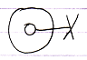

Class Connectors (Reference-Bound)
(inward)

Public Reference  Use As Class | Private Reference  Use As Class | Friend Reference  Use As Class
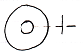 | 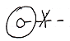 | 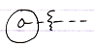
Public Reference  Class Set | Private Reference  Class Set | Friend Reference  Class Set
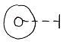 | 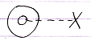 | 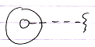
Public Reference  Class Get | Private Reference  Class Get | Friend Reference  Class Get
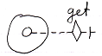 | 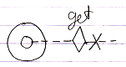 | 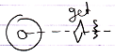

Class Connectors (Object-Bound)
(outward)

Public Object  Use As Class | Private Object  Use As Class | Friend Object  Use As Class
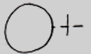 | 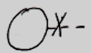 | 
Public Object  Class Get | Private Object  Class Get | Friend Object  Class Get
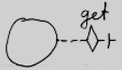 | 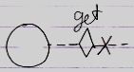 | 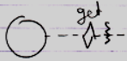

Object Class Set does not make sense, because the object class can not be freely set; it is only set on creation.

Class Get and Use As Class

For the Class aspect, there is a distinction between Use As Class and Class Get. They are different. Use As Class makes you use one symbol as the class for another symbol. That is how classes are most commonly used. That would be the result of an Object Get on the source object, followed by a Class Set on the target object. No Class Get is involved in a Use As Class action, which you might expect if you draw a parallel to the Object aspect.

Class Get gets a reference to the class object of an object. Traditionally this would be considered getting an object’s reflective data. You can use the reference to the class to your own discretion. Class Get is far less common. So Use As Class gets a fundamental notation, whereas Class Get has to make due with the ‘system command’ notation.

This is due to the behavior of the Class aspect. This is different behavior compared to the Object aspect. You just have to remember, that each aspect has different behavior, because it has a different purpose.

The funny thing about access controlling Use As Class, is that you are actually access controlling the Object Get for specific use in a class assignment.

Value Connectors

Public Value Get | Private Value Get | Friend Value Get
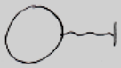 |  | 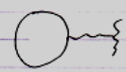
Public Value Set | Private Value Set | Friend Value Set
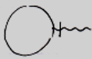 |  | 

Note that for the Value aspect the directions of Get and Set are switched compared to the Object aspect, because for the Object aspect, the access mark indicates the direction of the resultant line, while for the Value aspect, the access mark indicates the direction of the assignment. You have to remember, that each aspect has its own unique behavior.

Data Connectors

You can access control sub-objects, to apply some sort of write-protection to the sub-object. But that does not write-protect the sub-objects of the sub-objects. To collectively write-protect any sub-object, you can access control the Data aspect.
A preliminary notation for Data access is a triple wavy line (‘triple’ expressing multitude, ‘wavy’ expressing values or data).

Public Data Get | Private Data Get | Friend Data Get
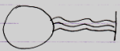 | 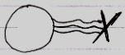 | 
Public Data Set | Private Data Set | Friend Data Set
 |  | 

Clone Connectors

The Value aspect is about copying the direct value of the object. But you can also copy the values of sub-objects up to a certain cloning depth. The could be any number of levels up to which the values of sub-objects are cloned. The diagrams below show access connectors for cloning at a depth of 2. That is just an example. Any cloning depth other than two can also be separately access controlled.

Public Clone 2 Get | Private Clone 2 Get | Friend Clone 2 Get
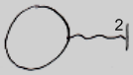 | 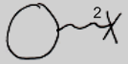 | 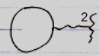
Public Clone 2 Set | Private Clone 2 Set | Friend Clone 2 Set
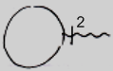 | 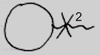 | 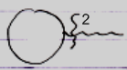

So cloning has the exact same notation as the Value aspect, but then with a number near the access mark, to indicate the cloning depth. It is simply that closely related to working with the Value aspect.

Execute Connectors

For command objects, being able to execute can also be access controlled. This is called the Execute aspect. Currently the Execute aspect adopts the ‘system command’ notation.

Public Execute | Private Execute | Friend Execute
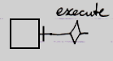 | 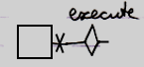 | 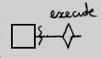

New & Annul Connectors

The creation of an object can also be access controlled. The New and Annul commands are access controlled using the ‘system command’ notation for now.

Public New | Private New | Friend New
 | 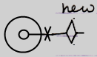 | 
Public Annul | Private Annul | Friend Annul
 | 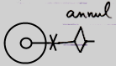 | 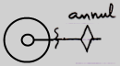

Interface Connectors & Other Connectors
There are also interface connectors, but interfaces as a whole will be cought up with in the Interfaces article group. Interface connectors work roughly the same as class connectors. In fact, any other aspect that will be introduced in the future will extend the set of possible connectors.

Preliminary System Command Notation
The access connectors using the system command notation have a preliminary notation. The exact notation system commands will get an update in the future.

Connections to System Aspects
This section covers any kind of connection between objects, that are a result of accessing system aspects.

Object Connections

Public Object Get Connection | Friend Object Get Connection
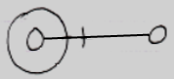 | 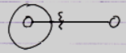
Public Object Set Connection | Friend Object Set Connection
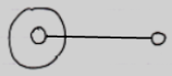 | 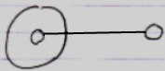

Remarks
The last two pictures are the same. Public and Friend does not matter for outward connections. Public or Friend access only mattered when establishing the outward connection. Outward connections are passive connections: direct connections to the target object. Inward connections, though, cause a Get command on each consult of the source symbol, so in that case an actual access takes place, and the distinction between Friend or Public access does matter.

Friend and Private Connections
Because there is not distinction between a Friend connection and a Private connection, Friend connections:

are called Private connections as well.

Class Connections

Public Object  Use As Class Connection | Friend Object  Use As Class Connection
  (outward) | 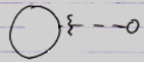  (outward)
Public Reference  Use As Class Connection | Friend Reference  Use As Class Connection
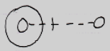  (inward) | 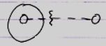  (inward)
Public Reference  Class Set Connection | Friend Reference  Class Set Connection
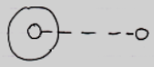  (outward) | 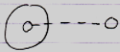  (outward)

Remarks
Use As Class and Class Set are covered here. Class Get is not covered here, because that is only used in an assignment, and assignments are addressed in other section: Assignment of System Aspects.

Object Class Set is not displayed, because the class of an object is only set on creation.

Value Connections

Public Value Get Connection | Friend Value Get Connection
 | 
Public Value Set Connection | Friend Value Set Connection
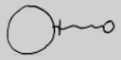 | 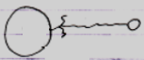

Remarks
Note that the indication of direction for Get and Set is switched for the Value aspect, compared to the Object aspect: Object Get is inward, while Value Get is outward.

Value connections are shown here in the section Connections to System Aspects, and not in the section Assignment of System Aspects, but Value connections are assignments, but they do not have an ‘assignment notation’.

What you can also notice is that outward Value connections do have access marks, while outward connections for the Object and Class aspects do not show access marks. This is because outward Object and Class connections are passive connections and outward Value connections are active connections, because an Value connection always requires an active assignment.

Data Connections
A Data connector such as the following:

Public Data Get

is an abstract connector: it represents any possible Get connection to a sub-sub-object.
Even though there is a Data connector, there are no Data connections. Any Get connection to a sub-object is be considered a Data Get connection.

Clone Connections
The diagrams below show access connections for cloning at a depth of 2. That is just an example. Any cloning depth other than 2 could be used.

Public Clone 2 Get Connection | Friend Clone 2 Get Connection
 | 
Public Clone 2 Set Connection | Friend Clone 2 Set Connection
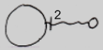 | 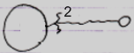

Cloning has the exact same notation as the Value aspect, but then with a number near the access mark. Cloning is that closely related to the Value concept.

Other System Aspects
The remaining aspects are Existance and Execute.

The essence of it is, that all system commands are separately access controlled. They all get their own access connector. The uses and implications are less important.

This part of the documentation displays connections that are a result of accessing system aspects. But for the Value aspect that means the display of an assignment.
And for Existance and Execute that also means something different.

Here you see again, that all system aspects behave totally differently.

New & Annul Calls
New and Annul connections are calls to the New and Annul system commands.

There are the following possible New and Annul calls:

Public New Call | Friend New Call
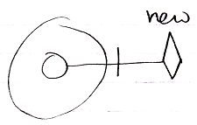 | 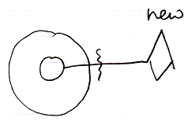
Public Annul Call | Friend Annul Call
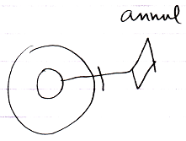 | 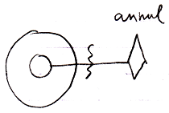

But the result of accessing New and Annul are the reference’s being Nothing or Something, which look as follows:

Nothing | Something
 | 

(As with the Set connections of the Object and Class aspects, actually accessing the symbol is history and it does not matter anymore if it was Public of Friend access that caused the result, so you do not need to see it in the diagram of Nothing and Something whether it was established through Public access or Friend access.)

The access connector notation of New and Annul were preliminary:

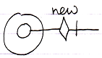

And here it becomes apparent why. The following diagrams show New and Annul calls and also the access connectors displayed right in the picture:

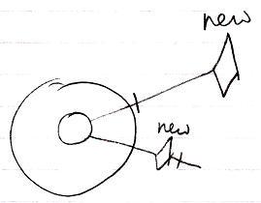 | 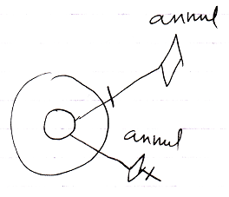

An access connector stands for a potential connection and should look like the potential connection. In the pictures above, the connector does not look like the actual connection, so the notation may need to change in the future. A potential connection is usually expressed as a loose end, so the potential system command call should also be expressed as a loose end somehow, so perhaps the following notation for access controlling a system command would be better:

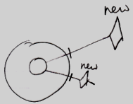

For now the notation of system command connectors is open to discussion.

Execute Connections
< You have to address the details in Using Command Symbols and the preliminariness of the system command notation must eventually be removed. And then you have to display just the actual connections (executable references to the command) that are already visible inside the more complex pictures now shown below. >

Access controlling the Execute system command for command objects may seem like access controlling the ability to call a command. But that is not true. You can access control a command’s Use As Class connector to make a command callable or not. You do not need to access control the Execute system command for that.

The essence of it is, that each system aspect can be separately access controlled. They all get their own access connector. The uses and implications of access controlling the Execute command are less important for now. Access controlling commands is covered later separately.

The Execute access connector was introduced as follows:

The result of access controlling the Execute command is that the command can only be executed by Friends. The command can not be referenced by a diamond shape (an execution) unless it is from a Friend object. Access controlling the Execute aspect disallows execution of the command.

So this is allowed (see Execution in the diagram):

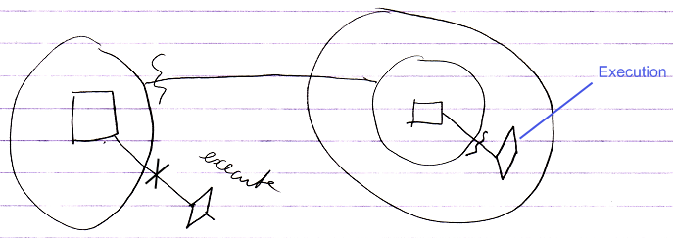

It is allowed, because of the friend declaration on the left.

When you take away the friend declaration, execution is no longer allowed:

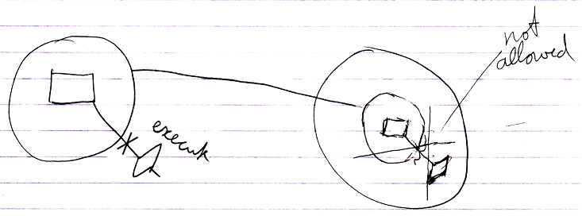

But non-executing references to the command are allowed:

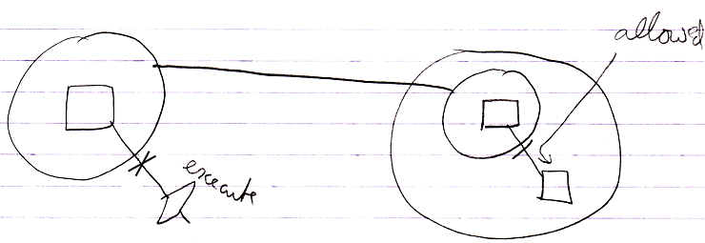

The notation for access controlling system commands is not final yet. But because an access connector should be a depiction of a potential connection, the access connector for the Execute aspect might eventually have to look as follows:

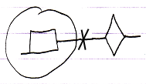

With not even the word ‘execute’ in it anymore.

Assignment of System Aspects
This section demonstrates how accessing system aspects looks in assignment notations.

Only Object and Class Assignments
Only Object and Class assignments are covered here.
Value and Clone assignments were covered in Connections to System Aspects.
The Execute aspect does not involve assignment.
The Data aspect does not work with assigment either.
The Existance aspect may involve assignment but that is not covered here.
So it comes down to Object and Class assignments.

Object Assignment

Public Object Get  in Assignment | Friend Object Get  in Assignment
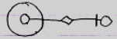 | 
Public Object Set  in Assignment | Friend Object Set  in Assignment
 | 

Connectors & Assignments
The following diagram shows Object Set in an assignment, and the Object Set access connector:

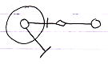

The access mark in the assignment and the access mark in the connector have opposite directions.

This is because for the assignment notation it was decided, that an the access mark expresses the direction of the assignment, and the connector expresses the direction of the potential connection, so the direction of the result. It was decided, that it would be clearer to express the direction of the assignment inside the diagram notation, instead of letting the assignment call express the direction of its result.

Class Assignment (Reference Bound)

Public Reference  Use As Class  in Assignment | Friend Reference  Use As Class  in Assignment
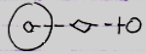  (source is inward) | 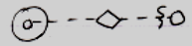  (source is inward)
Public Reference  Class Set  in Assignment | Friend Reference  Class Set  in Assignment
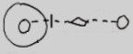  (target is inward) |   (target is inward)

Class Assignment (Object Bound)

Public Object Use As Class  in Assignment | Friend Object Use As Class  in Assignment
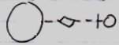  (source is ‘outward’) |   (source is ‘outward’)

Class Get Connection
At first glance you would guess, that Class Get in assignment looks something like this:

But that is Use As Class. The smaller circle on the left becomes the class of the circle on the right, requiring an Object Get, followed by a Class Set. Class Get is far less common: it retrieves a reference to the class of an object, and then you can assign the class to another object.

Using Class Get always requires the system command notation, because the more fundamental notation above is used by Use As Class.

The system command notation is not yet final, though. The Class Get access connector may look something like this:

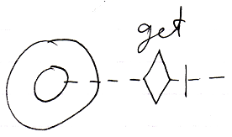

Yielding over the class from one object to another may look something like this:

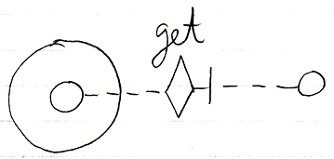

Even though the eventual notation does not look like assignment, it still involves an assigment to the object on the right, whose aspect is changed.

Yielding over Class aspect:

Public Reference Class Get  Connection | Friend Reference Class Get  Connection
(source is inward) | 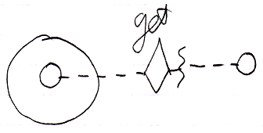  (source is inward)
Public Object Class Get  Connection | Friend Object Class Get  Connection
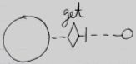  (source is outward) | 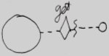  (source is outward)

An alternative: assigning Class object to Object aspect of other symbol:

Public Reference Class Get  Connection | Friend Reference Class Get  Connection
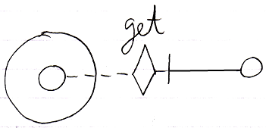  (source is inward) | 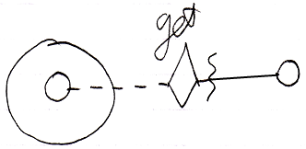  (source is inward)
Public Object Class Get  Connection | Friend Object Class Get  Connection
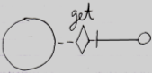  (source is outward) | 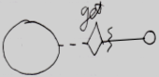  (source is outward)

System Command Calls in Assignment
Different assignments require different accesses to different aspects as shown in the overview below.

Public Object Get  in Assignment | Public Object Set  in Assignment
Object Get ←  Object Set → | Object Get →  Object Set ←
Public Use As Class  in Assignment | Public Class Set  in Assignment
Reference . Object Get ←  Object . Use As Class ←  Class Set → | Reference . Object Get →  Object . Use As Class →  Class Set ←
Public Class Get  Connection | Friend Class Get  Connection
yielding over Class aspect | assigning Class object to Object aspect of other symbol
Reference Class Get ←  Reference Class Set → | Reference Class Get ←  Object Set →

Assignment between Friend Members
A connection or assignment always involves two objects. In a connection or assignment that involves a friend object, the access mark is a wavy line. It is only clear which of the objects are friend-accessed from the friend access connectors.

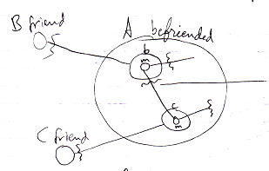

In the example above both members involved in the connection are friend. It is only clear which objects in the access are friend from the presence or absence of a friend access connector.

In the following example, one of the members is public while the other one is private.

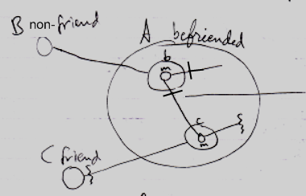

Member m of reference b is Get-public. The access mark of the connection is changed to a Public access mark, because the Get-access is public, and an access mark expresses the Get-access. To see which member involved in a connection or assignment is friend, you should look at the access connectors and not necessarily at the access mark on the connection or assigment call.

Perhaps in reference assignment you do not always need an arrow, because when the source is inward, it is implied, that you assign a reference.

Why the Wavy Line?
The wavy line is already used in the language to express ‘value’, ‘data’, or ‘content’. Now it is also used to express friendship.

Compared to the other line types:

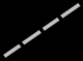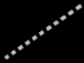

The wavy line expresses something special. Wavy is also like the symbol ~, which means approximate or ‘under certain conditions’. And under certain conditions you can access Private members, which are then denoted with a wavy access connector. So it looks like a straight access connector (meaning Accessible), but then under certain conditions, so the line is wavy. A wavy line expresses special access, conditional access.

Wavy lines already expressed value, data and content. Using wavy lines in the friend notation lets you access the Private value, data and content. So there is a vague parallel there.

Correlation With System Commands / Assigment
System Objects,
2009-07-08

Extend the ‘Calling a System Command’ notation in the System Objects chapter: the line type should indicate the aspect. System Commands are so fundamental, that they deserve a more basic notation.

JJ

There may be a difference between the fundamental notations of
system commands that do return something and system commands that do not return anything.

Maybe it is nicer to also change the line type of the access connectors
and assignment calls or system command calls, so that the whole expression
is in the same line type, like dashed or dotted. That way it might be clearer.

Line types for shapes and access marks is cosmetic, though, not required,
but might make the picture much clearer.

An access connector represents a system command definition: a potential call to it.

So the exact correlation between system commands and access connectors and access connections.

The main points would be:
- Access connectors represent system command definitions: potential calls to system commands.
- Inward directed connections will perform active gets on each
Outward directed connections are passive: it is a direct reference to the target object.

The System Objects articles should incorporate the difference between object-related aspects and reference-related aspects.

(Notational issues:)

Private & Public,
2008-06-10

When a member is accessible as an object, class or interface, this is a solid line,
when a member is accessible only as a class, this is a dashed line,
when a member is accessible only as an interface, this is a dotted line.

JJ

< Om iets alleen te mogen gebruiken als class kun je de access connector line gestreept tekenen (en ook de shape). Als je iets wel als obejct mag gebruiken, alleen het wordt alleen gebruikt als class kun je de shape met gestreepte lijn tekenen maar de access connector (inclusief line) ononderbroken laten. >

I forgot the pointer to pointer connectors and also the Add and Remove connectors for lists.

Miscellaneous Issues

Deeper Exclusion
Apart from controlling access to the type’s own procedures, a type can also control publicity of procedures of its chilren. That way you can publish a child, but make some of its public procedures inaccessible outside the parent. This way you can also exclude members of a base type. A parent can’t make a child’s procedure inaccessible to the child itself; it’s the child’s own procedures.

You can also exclude members of ancestors even further down the hierarchy.

Forms of exclusion other than Private are just called exclusion or privatising.

You can only make a procedure of a child less accesible, never more accessible. The parent can’t publish a child’s procedure that the child defines as Private. A child can’t put restrictions on how its members are privatised by the parent, so a parent has full control over the exclusion of the procedures its ancestors.

Exclusion access controllers are also called access modifiers, because they modify formerly set access controllers.

Inheritance, Exclusion,
2008-10-15

This is also a blackboxing thing...
... but I put it in inheritance.

JJ

Inheritance, Exclusion,
2008-10-15

Because it is complexity hiding,
it is blackboxing.

JJ

Exclusion,
20008-10-16

But it is just access control,
so it is blackboxing, not inheritance.

You can apply access control combined with inheritance, to further specialize a class, object or system.

JJ

Exclusion... so a grandparent imposing extra access control onto its grandchildren...
Another advanced topic to cover at the end.

Gee, Public and Private are already a form of exclusion,
because the parent object is imposing restrictions to access
to its sub-objects ( the references it contains. )

When you make it private, it means that it is only accessible to friends...
hmmm...

Deeper exclusion protects members of sub-objects,
but how much can those sub-object members be protected, if they might
also be referenced elsewhere. Somehow they have to be protected from
being referenced elsewhere... fixed logical residence?
What if you reference the object from elsewhere?
Somehow it needs to be controlled, that an object is always referenced
THROUGH the object that protects it...
There is a link with user access control here, but I won't go there yet.

Yeah, there is a discrepancy between controlling access and the fact that
containment is now a volatile thing. Fixed containment needs to be
imposed in order to establish access control...

Multiple objects can impose another access modifier upon the same object,
so where are all these access modifiers stored?
At first it will only be access modification of a direct reference,
which is already under control of the parent object.
But for deeper objects it is different...
so I am not sure yet... are those deeper objects supposed to
be exclusively contained by the grandparent object?
Or can they also be referenced elsewhere,
so that the grandparent has to remember the grandchild access modification
settings and not just delegate that to the child, that holds the grandchild?
I'm not sure.
Perhaps details like that should be worked out when actually turning
this language into an actual programming environment...
and we should keep the focus on the general idea?

Private, Public is exclusion

< Public and Private are an application of exclusion. So then the base of the explanations can be only accessible and inaccessible. >

Exclusion is the primary method for access control. Friends is the method to make exceptions to the privatisation imposed by exclusion. A procedure or type can make any other procedure or type they can reach a Friend, meaning that that procedure or that type has access to all members privately accessible in the befriended.

> And cover deeper access as well.

> Also cover how a fixed logical residence allows parents to impose a permanent, non-volatile access control. Qualified access to an object without it being a fixed logical residence does not guarantee access control imposed by the qualifiers. But if it is a fixed logical residence, the qualifier is mandatory and you can not go around the access control, that it imposes.

Protected
There is another basic access controller in addition to Accessible and Inaccessible: Protected.


Protected (By the way: it’s not an arrow.)

When a procedure is Protected, it means that it’s inaccessible if contained in a circle, but accessible if contained in a triangle.

 | ≈ | 
 | ≈ | 

A circular descendant automatically privatises a Protected member:

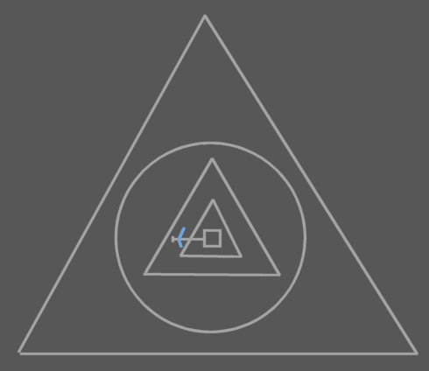 | ≈ | 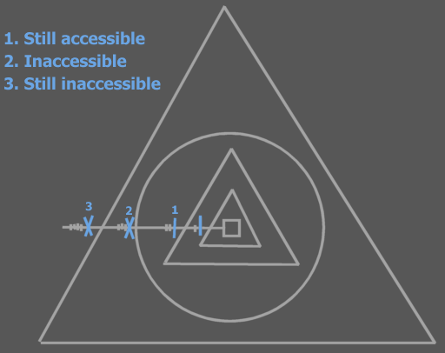

The member isn’t accessible to any higher symbols than the first circular descendant.

Formally the choice of making an extra Protected access controller seems totally arbitrary. In practice there are situations in which it’s useful to work with members that can be accessible to the interface holder, but not accessible to the outside.

Protected is used in exclusion only. It can not be used for ‘outcommenting’ code.

A triangular mark:



Is used to indicate that a symbol that owns the line is Protected, meaning, that it is only accessible when the symbol that owns the line is a triangle. A triangular mark is not an arrow.

And then there is Protected. A funny one there. It should be an extra issue, explained after everything else is explained, because it works the same way, except that the befriended object should be referenced with a triangle / should be the friend object’s base object.

Private & Public,
2008-06-10

Protected:

Something needs to be done with protected.

JJ

Being a friend grants full access to the private and protected members of the befriended.

Interfaces,
2009-06-28

do not forget that the protected access modifier can not only
be used for object access, but also for class access and interface access.
(Class Get, Interface Get, etc.)

JJ

Internal
< Also called Friend in VB6 >
< better term: internal >

<< I have to note the application of the Visual Basic Friend access modifier. The basic access controller Friend isn’t required (Public Friend and Protected Friend). Friend Basic Access Controller means that you make a procedure’s own globality a Friend globality.

Yes, but for the effect of the Visual Basic Friend access modifier you also need to deprive global members from being accessed outside the globality. And that is done with globality level restriction.

So the effect of the Visual Basic Friend access controller is replaced by • making the globality a friend of the procedure and level restricting global procedures.

NO! It’s just making it Globality Up 1! Nothing Else! Do not use a Friend Globality for specific procedures!
>>

Friend for reference
Means access only anywhere within the globality, but not inside embedded globalities.
< 2008-10-10 That was the VB meaning of Friend. >

A procedure can contain variable objects. The public ones are parameters. The friend ones are parameters within the current globality.

< Old VB meaning of Friend >

< What place the VB6 keyword Friend has in black boxing, I do not know. this is a detail even less prominent, than Protected, which is also a detail later discussed. VB6 keyword friend has to do with access from within globalities. >

Objects Take Over Class Access Control
< And references take over object-access control. >

… is objects taking over friend relations from classes as straightforeward as you’d think?

When it is classes, the friendship counts for all the objects derived from that class.
Usually, access to procedures is controlled in a class and each of its objects adopts those same access settings.

Side-Issues

Private Names

Private Names,

A name being private, even though the reference is not.
It's a detail, but it is an issue.

It is important to separate the interface from the implementation.
The implementation is only visible in the target definition.
> 2009-06-26: And inside references of friends.

For execution control commands, you have to be able to hide the name of a symbol when you call it. So while the symbol itself can be part of the interface, the name could be part of the implementation, which is not visible unless you’re editing the definition of something.

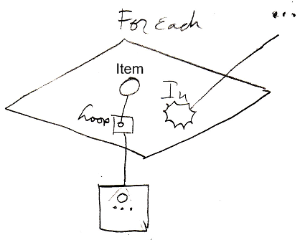
The cirlce inside the loop parameter is not named. It is an unnamed parameter, that might be referenced through the name of the variable it is pointing to. But I’m not sure about that.

JJ

Inclusion
Apart from a decisive access modifier, you can also give a procedure a suggested access modifier. This means that when you put an object in a type, a procedure of the object will get its suggested access modifier, for instance Private, but if its decisive access controller is Public, then you can still upgrade it to Public. This is called inclusion. The suggested access modifier is always set to less accessible than the decisive one. A type can also give suggested access modifiers to procedures of ancestors.

> 2009-07-06: Inclusion might only be useful for programmers. But programmers get automatic friend access, so real, exclusive access control is already the suggestion and everything can still be included, so it might be an unuseful concept.

Black Boxing and User Access Control
Access control will be fully managed
by the access control module, even for
access controlling an object's members,
making the members only accessible
to the direct container of the member in
order to hide complexity from the outside,
or to to protect the object's data.

But that form of access control is so
important in programming software,
that it is introduced earlier
as the concept of Public & Private,
before access control is worked out
as a complete solution to security.

Maybe access controllers are a step into the direction of security. Maybe security should be a kind of advanced access control.

Interesting idea for user access control:
a constant in a program is a variable that can
be changed by a programmer, but not by a user
and also not by the program itself.

Public & Private,
± 2008-09

This project should be the working out
of the concept of Public & Private, even
before it is integrated into the complete
Access Control concept.

Public & Private need a preliminary notation,
and preliminary explanation, so that the concept
can be used in explanations of
coding concepts whereever required.

JJ

Private & Public,
2008-06-10

Access Controlling System Aspects:
Save for user access control, because this is about different roles:

You can have friends for reading, writing
or changing (add and delete symbols.)

JJ

Programmers and Users
… = user access control

privates visible in friends, and in definitions when you have user access to it, so you are a programmer, not a user.

Something like that…

Private & Public,
2008-06-10

Editing definition:

> 2009-06-30 Some of the ideas here are wrong, but the general idea should be thought of about editing the definition.
Friend access is different from access to private contents
only when editing the definition.
> 2009-06-26: No. this is user access control. Some users are authors of a definition. Some are not. Do not confuse it with private/public concepts.
It's the difference between friend for reference,
and friend for change.
> 2009-06-26: Bull, see last comments.

If you are a friend for change (not for reference) for private contents,
you will only see the private contents if you are at logical target the definition.

JJ

Details, Cover Last

Level Limitation
< Exclusion is restriction set by a container. Level restriction is like exclusion set by a child for the container. >

> 2009-06-27: I am not sure why I would need a child object to restrict the number of levels up it is accessible… why? for protection? Well… I would better resort to use access control for such protections…

Basic access controllers are decisive, but level limitation adds additional restriction.

Level limitation is paired with the basic access controller.

Pairing object level limitation with the Public access modifier, makes a procedure public only to limited number of levels up the ancestry.

Public Up 2

A procedure with this access modifier is accessible but two levels up the ancestry. Outside those levels, the procedure is inaccessible.

No object level limitation: Public
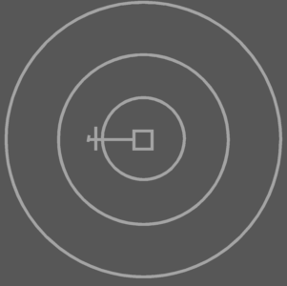 | ≈ | 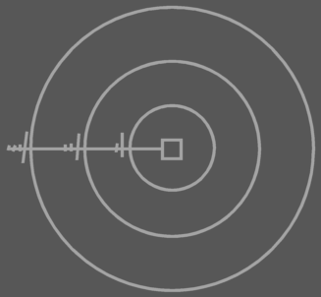
Object Level Limitation: Public Up 2
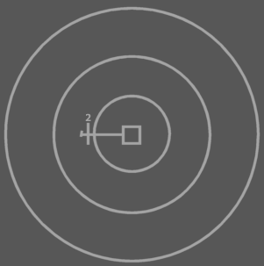 | ≈ | 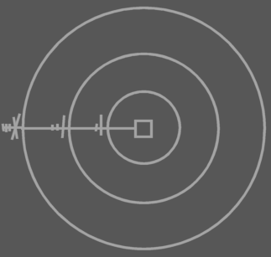

Level limitation works the same for the Protected access modifier, but gets the additional restriction that comes with that access modifier:

Protected Up 2

A procedure with this access modifier is accessible two levels up the ancestry, but inaccessible outside the first circular descendant.

Protected Up 2, contained in three triangles
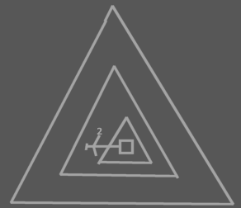 | ≈ | 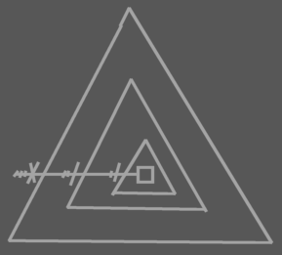
Protected Up 2, contained in a triangle contained in two circles
 | ≈ | 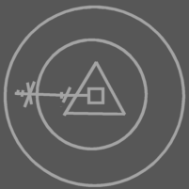
Protected Up 2, contained in three circles
 | ≈ | 

Level limitation can also be applied to deeper exclusion than Public and Protected. So a parent can impose level limitation on a child procedure.

Level limitation on deeper exclusion
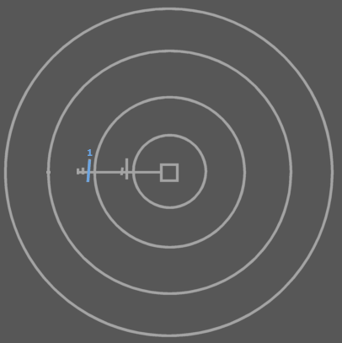 | ≈ | 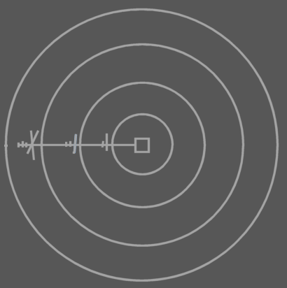

You can also apply level limitation for on symbols shalower than the target procedure.

Level limitation on deeper exclusion
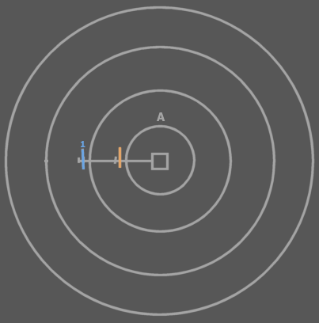 | ≈ | 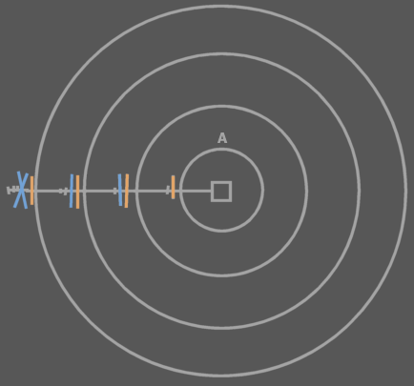

Level limitation is defined there where it doesn’t have effect yet. It only has effect higher in the ancestry. Basic exclusion is always defined there where it has effect. So level limitation automatically excludes members at n levels up the ancestry.

< Figure out a better diagram notation. >

Maybe call it Level Restriction.

Globality Level Limitation
<Pictures>
Apart from object level limitation there is also globality level limitation.

Public Globality Up 1

When an access modifier is paired with a globality level limitation, the access modifier works normally n level up the globality ancestry. But for higher globalities the member is inaccessible.

Public
 | ≈ | 
Public Globality Up 1
 | ≈ | 
Public Globality Up 2
 | ≈ | 

Protected Globality Up N works the same as Public, but adds the extra restriction that comes with protected.

> 2009-06-27: Globality level limitation is that VB6 Friend idea. That is probably why I also introduced object level limitation to begin with: as a bridge towards the concept globality level limitation. It is more like overkill… I do not know yet how VB6 Friend access is supposed to look, but perhaps you’d better just appoint inside which globality you still have access to it or something, instead of coming up with Object level limitation and only to build globality level limitation only to have a substitute for VB6 friend access control.
> 2009-06-29: But level limitation and then globality level limitation is a lot of systematics to introduce just to facilitate a VB Friend access modifier.

<Pictures with that? >

<‘Globality Up 2’ is too long, because Public Globality Up 1 will be used commonly. Visual Basic’s Friend access modifier is the same as Public Globality Up 1. I might need to invent a specific term for Public Globality Up 1. I won’t use ‘Friend’, because that would conflict with >

Access Controlling Globals
> This issue is more important than level limitation and globality level limitation, but those two concepts are used in the implementation as laid out below (the implementation will probably change in the future.

Access modifiers in Globalities:

- Global Inaccessible
- Global Private
- Global Public

To understand what happens when procedures inside globalities are given access controllers you need to view the globality as an object, that is referenced from any of its ancestor objects:

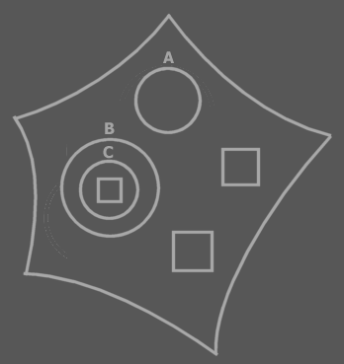 | ≈ | 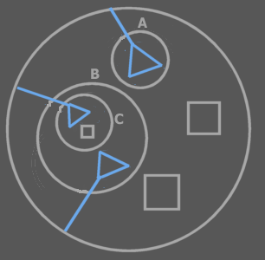

If a global procedure is Inaccessible, it’s just not accessible at all (‘outcommented’), so not really global either. If a global procedure is Private, it’s not really global either, only accessible by the globality object itself, just like something private of a circle object. If a global procedure is Public, then it is global. It is then accessible from any ancestor within the globality.

When a global procedure is Public it is however also accessible outside the globality, as a public procedure of the globality object. For a procedure to be global inside the globality, but not accessible outside the globality you use globality level limitation: Public Globality Up 1.

> 2009-06-27: And here I am attempting to differentiate between VB6 Friend on a global level and VB6 Public on a global level. I am trying too hard to make a match between access modifiers I know from VB6 and C++ and match them with a new language. I was too afraid to reinvent each atypical concept, and insisted to put those concepts inside a single systematic. That is why I went to such an extent with this level limitation stuff. Ok, I can respect it now. It is an attempt to put those access modifier situations into context, but I think this should only be an intermediate implementation of it and in the near future an easier approach needs to be come up with. This stuff here should be seen as just a brainstorm.

It is not a permitted to make a global procedure Protected. A pentagon is not exchangable with a triangle, so Global Protected wouldn’t have much meaning.
> 2009-06-29 That, by the way, is not true anymore. You can reference a globality triangularly if you want.

Access Modifiers in Globalities needs to be further thought through. It gets tricky as you put it in diagram code.

Simplified Access Connectors
Could also be called: Access Control Presets.

< Wat wel zo is is dat de standaard access control van system procedures er voor zorgt dat je niet zo maar rare dingen kan gaan doen. Erg belangrijk als je effe snel iets programmeerd, dat je de echt rare effecten uitsluit zonder extra moeite. >

< 2009-06-29 Bedoelde ik hier oorspronkelijk mee de macro-keywords voor access control? Zoals bijvoorbeeld Public Read-Only Value ofzo? >

<
I don’t have a special notation for publicity of Set procedures.
Set public or not is kind of like read only or not. Maybe I need a read only notation.

Write only is also common, though. For instance of procedure reference input parameters.
>

<Also cover constants>

When you give a system procedure an access controller, access to the procedure or object represented may get a special name and diagram notation.

An object symbol with an accessible State Read procedure, but no State Write, is called a Read Only Object.

An object symbol with only a Type Read, can be considered just a Type. Not an object or interface.

An object symbol with only an Interface Read, can be considered just an Interface. Not an object or type.

…
Etcetera, work it all out

Standaard access controllers
- Standaard zijn Add en Remove geblokkeerd. Zo zijn er nog meer dingen standaard geblokeerd
De klasse kan zelf initial access controllers aannemen die je ook weer kunt veranderen.

Something is constant if it can be set by programmers , but not by users.

< By default everything is public. When studying the access configuration of a symbol you might only want to see what differs from the default >

<The standard access modifiers for system procedures of procedure symbols directly inside a procedure symbol are different from procedures directly inside object symbols. For instance, Symbol Get for Reference of a clause is Private by default. Symbol Get for Reference for an object member is Public by default>

A call is by default private.

The access controllers of the procedure’s sub objects determine which purpose they serve. Maybe I should write a section about that in Access Control.

Required and Optional parameters as well as In, Out and Thru need to be rediscussed in Access Control, because it may be so that it is required for you to Object Set a parameter, while the procedure changes the state of the target
object. This is like thru too, but a totally different fashion and there are more ways of throughput.

If a configuration of any sort is a common one, it might be nice to make something like a typedef so you give the configuration a name of its own, Like if you commonly use ‘Public Up 1 Globality Up 2’, you might want to give it a different name.

Consider combining the concepts Presets, Macro-Keywords and just a brainstorm about nice-to-have keywords for common access control situations.

Best example: Public Read-Only Value. Read-Only Value.
You do not even have to introduce completely sound systematics, you can also just shed light on the general concept.

Those 'macro' access modifier keywords are not very important.

There may be an analogy between macro keywords and a C++ typedef.

(perhaps only for names)
( I think this issue was also temporarily put in the Parameters chapter originally.)

But what about ‘making a command Private’? What do you mean by that? You can access control the Execute system aspect of commands, but that does not make other aspects of a command object private, such as the Object Set aspect (turning the command symbol into a command reference).

Should there not be something implied when a connector is not there: in a friend relation this will create a lot of connectors… so no connectors should mean everything is accessible in a friend or one connector should be the placeholder for any other connector… or some common connectors and others (such as Class Get implied )

In definitions, publics could also be differentiated from privates by privates not getting access connectors? Well… friends can access them, so they need access connectors…

When you have to display a lot of connectors, you might summarize them, and when you float over them, they expand into options.
Maybe first you have an object connection line without a connector. You float over it, it splits up into an class, interface, object and value line, you float over one of those, it splits up into for instance Object Get and Object Set. I know that does not cover all the options, but it might be an idea to display the connector summary and fan it out when you float over it.

Explicit display that something is private
is optional.
Explicit display, that something is public
could be made mandatory, because
is it not overhead in notation: it clearly
indicates a connection point.

If you do not see any access connectors, do you assume, that everything is accessible,
or that nothing is accessible?
That is a good question for the display of access connectors.
But not essential to cover.

Questions:
- Can you make it an option to only show befriended commands inside an object, instead of friend and non-friend commands.

I am not sure yet. It is not clear.

Another fact:
One of the most important things to access control is an object’s being accessible at all or having read-only access to it. Another important access controlling capability is to only be able to retrieve (and set) the Value of an object. Perhaps, if you state that Set is public it automatically means, that Get is also public, and if you state that Get is public, it automatically imples that Set is private.
> Perhaps it is interesting when one user writes a value, but other users can not read it out, but that is sort of outside the scope: that is user access control. System access control is covered here.

Perhaps that way the number of possible access controllers becomes more limited, so you do not have to display each possible access connector: Object Get implies any kind of connector.
Access controlling for just allowing a Class Get is stupid as well: who wants that? Who wants to only be able to access the reflective data of an object, but not the object itself?

The notation is simply drawing the symbol a dotted line or a dashed line,
which makes it only usable as an interface or class.
How you should express something only being usable
as a class but not as an interface is not clear to me.
I do not think I really need that and I do not think I
need to clear that up.
But whatever, this is for later.

Also useless: allowing Set but not allowing Get… if you can already write it, why not allow reading it? Is there any point to that? The important thing is write-protecting, or not access at all… but read-protecting, while you could write to it? It seems unlogical.

Downsides to Black Boxing
Data protection does not really have a downside.
Complexity hiding, though has a downside.
Complexity hiding does has benefits: it allows you to focus on overview, focus on the main point of a system, object or command.

In professional software development it is a blessing, that you get access to a wealth of objects that provide functionality for you while you do not need to know or see exactly how it works inside. It allows you to focus on the main point of the progra,
If you know how to properly use them, there is no downside.

The downside of complexity hiding, though, is that you do not know what is going on inside the object you are calling. You may think something you call upon is a simple procedure, while in reality you are consuming so much the computer’s power that it makes your application perform really poorly and probably puts a break on your whole computer’s performance. You might not want to know all the details, but when something is abstracted you do not know exactly what is done.

There are methods to overcome this though. It is not concrete yet, but the inner complexity of an object or command could be expressed by size. That will give you a relative estimation of the complexity of what you are calling upon.

< … >

Get For Access and Get For Copy
Access can be controlled for regular procedures this way. You can also control access to system procedures. When you make an object Private, you’re in fact making its Object Get procedure private (which can even get different separate access controllers for Access and Copy, Run Time Copy and Design Time Copy).
> 2009-06-29: The difference between design-time and run-time is gone in the new language. There is only differentiation between program authors and users through user access control.

There might be a separation between access controlling Get for Access
and Get for Copy... but not much more.
I used to have a difference between Run Time Copy and Design Time Copy,
but that is bull now, because there is not difference between run time and design time.
There may be a difference between different types of users: authors and users...
but that is user access control, which is not covered here.

<There are also situations in which you want to disallow copying an object reference to an argument, but only allow consult of the argument. (that’s access control of system procedures, actually)>

Inaccessible System Aspects
What if you want an aspect to be inaccessible to even friend objects.
Then the only one able to access those aspects is a programmer…
That is strange… giving nothing in the system access to something, but still the programmer can access it. That is weird.

Let’s stick to the plan where either everything is accessible or a selection of thing is accessible.

Compared to Traditional Black Boxing

> Deals with the two differences to traditional:
- Not only commands are friend with their object
- Containment and referential interchange.

> This overlaps with issues put under Notation.

Public & Private,
2008-09-15

Private means on the inside, Public means from the outside.

JJ

Public & Private,
2008-09-17

So Public does not means that you automatically have Private access as well.

JJ

> 2009-06-26: The last two ideas do not apply anymore. Public and Private will not have anything to do with outside or inside… Privates are accessible to friends… whether those friends are on the outside or on the inside.

Perhaps you could also work out the traditional implementation of public and private.
In that setting the original notation is usable.
Now it is all changing. Perhaps it will create clarity if you isolate the original idea.

It is superseded by the Friendship idea. And later, the Friendship idea will probably
be superseded by Access Control: public and private and user access control are the same concept.
But you have to make dues with intermediate solutions. So the traditional idea behind
Public and Private is also important.... maybe.

The main problem with the original idea about Public and Private,
is that a programmer does not define a containment structure,
and there is only a referential structure...
Something contained inside another thing can easily also
be referenced elsewhere. This counts for methods too,
so they are not exclusively part of one single object / class.

This creates problems for the traditional approach of Public and Private.

Who knows. Maybe the whole idea I have now about the Black Box
principle will totally change in this project.

The main problem I still see, is that in the new system, containment
is not so actively set by programmers anymore, because you
are mainly working with a referential structure, which makes
the containment structure more volatile.

It is not so much a Private member’s being protecting from the outside anymore, which is the traditional view on black boxing. It is about a Private member’s being protected inside its circle of friends and protected from non-friends.

Outside the circle of friends the black boxed contents are not even visible. That’s the way black boxing is still directly depicted in the diagram.

However, a member is made private, accessed from its container. So it is a matter of inside-outside the container (the container, that makes its member private). But the private member is not accessible only from within the container, it is accessible from the outside to Friends of the container.

So there is a slight shift in the view on Black Boxing.

But you can have two views in diagrams: a friend accesses a private member going from outside to inside, but you can also have the friend displayed inside the befriended, accessing the private members referencing from inside the friend to outside the friend, but inside the befriended.

Comparison to traditional black boxing,
2009-07-01

Hoe komt het black box principe nog naar voren? Wordt dat black box principe letterlijk genoeg zichtbaar?

It is so incredibly referential. Euwch.
The thing missing is the ‘accessed on the inside’ aspect, that in traditional black boxing was there. This is because in traditional OO you do not see that you are accessing a this parameter when you are accessing members of this. So it seems you are accessing things directly, while really you are accessing the members of the this object.

But I sort of miss the idea. Perhaps you’d want to get it back. This will only be possible, if you do not express access to this members as an access to a member of the argument, but as an access to a member of the parent object. So then instead of referentially displaying a this-argument inside the command, and a command inside the object next to it, you have to display a command in an object and .
But this is more for automatic containment (or relations). This is the discrepancy between automatic containment and displaying bidirectional relations, not to be covered here. But it is to be emphasized here. Perhaps you do need to show the less-referential approach, and the inversion of it and also show the referential view. Both notations. Because black boxing is about containment… and containment is a little lost.

For the time being this all will be put under ‘Comparison to Traditional Black Boxing’, which is not called a main issue for nothing.

How stupid is the older notation of public and private when you use it in the less-referential containment notation?

I have to make dues with the fact, that there are two notations: one with one symbol displayed inside the other with the reverse relations implied, and a notation with one symbol displayed inside the other, but the inverted containment right next to it, and them being connected together.

JJ

A command’s access to a parameter’s privates or only its publics.

< Perhaps save this for the ‘traditional black boxing’ section: >
A typical situation of friendship in object oriented programming is where an object has private and public data, and there are friend commands. The commands can access the private data of the object, thus becoming the protectors of the object’s private data.
This is a typical situation in traditional object oriented programming: class methods. In the new computer language it is a little different: instead of having a class with methods in it, there is a class or object with friend methods, that are independent entities, which have access to the private contents of the befriended object.

2008-05-18

Access to the private contents of a class creates a tighter bond between a command and a class. This concept is important.

JJ

Public & Private,
Friend Access,
2008-09-22
(out of the original document Commands & Classes Loosely Coupled)

In the new computer language’s implementation of parameters, commands only become part of a class if the class is used for one of the parameters of the command.
This makes it possible for a command to become part of multiple classes.
This is a richer and more dynamic approach, than object oriented programming languages. You may now think you are loosing control over the system, if a class gets so easily extended with more commands. But you still have control, as will be explained in the Interfaces article group.
There is one thing however, that’s missing from the story. In C++ and other object oriented programming languages, there was one parameter of a global method, that was the this-parameter. The class of the this parameter determined which class the method would be part of. That parameter was the only parameter in the method, whose private contents could be directly acccessed by the method. This is the one thing missing in the story of Parameters: when does a command have access to the private contents of a parameter? The answer lies in Friend-access. A command has access to the private contents of a class, when the class declares its command to be Friend. When a related object is declared Friend, then the related object can access the private contents of the one that declared it Friend.

Commands do not decide on their own whether they have access to a class’s private contents. A class grants a command access to its private contents.

This makes the command more part of the class, but a command is still a separate entity, that can apply to multiple classes.

Private members of a class are useless, unless there are commands that use these private contents. So the informal connection between classes and the commands, that is established by the class’s granting the command access to its private contents, is very tight, and those commands are actually the protectors of that class’s private contents.

Classes giving commands access to their private contents formally is a form of access control. But informally the commands, that have access to the private contents of a class, are the protectors of that class. The class appoints these protectors. Commands do not decide on their own to become such protectors.

JJ

Brainstorm

In traditional black boxing in object oriented programming an object had commands and each private member of that object was accessible inside that command.
In the new computer language there are the following differences:
- A command is not part of a specific object or class
- A command and an object are basically the same thing
The main idea for the solution is Friendship.

…

If the friend object is a command, then if the command has a reference to that object, from within the command, you can reference anything private inside the friend object. This is analogus to the this-argument of a command. The private contents of an object passed as the this argument can be accessed from within the command. However, in the new computer language a command can have multiple this-arguments: befriended objects.

So friend commands are like class methods.
< state that every command with a parameter with a class becomes that class’s method, but not as tight a bond as a friend method. >

In traditional black boxing it only applies to friend commands (class methods) and their befriended objects (this-arguments).
But in the new computer language you can also have:
- Friend objects of befriended commands and
- Friend objects of befriended objects
- Friend commands of befriended commands
In the first situation an object can reference access the private contents of a command. That sucks from an object oriented programming point of view, because this does not protect the command’s private variables and the command’s procedure definition. But that is just what friends are about: they ARE protectors of an object’s private members. They have full access to it, and take responsibility of it. That is also what class methods do in traditional object oriented programming.

In the second situation one object can access the private contents of another object. That is exactly the same as the C++ implementation of friend classes.

Actually, class methods & C++ friend methods are the exact same concept in the new computer language.

> 2009-07-06 Actually, they are not. Friend in the new computer language applies to a specific relation counterpart, while friend in C++ applies to any relation between objects of class A and an object of class B.

In the third situation a command gets access to another command’s private contents, making the command’s local variables and definition accessible to the other command.

I am not sure what you are supposed to do with getting access to the private members of a command… but in the simple setting it should be possible.
However, to prevent circular creation of command calls on (indirect) recursive calls, in the commands topic it was decided to only create a command’s private contents, just when it is running. So in that setting there is no point to the situation where a command gets befriended.

Other Brainstorm Items
The complexity hiding aspect is clearly expresses the black boxing concept in the diagram. It is the hiding aspect that makes the black boxing, not the inside-or-outside aspect.

Using command symbols
< Cover ~all (?) the notations when one of them is a command symbol? It is to point out how it would look in the traditional approach where commands are friends with their class… >

2009-07-20,

< Access controlling executing a command is inadequately gone into yet. >
< Perhaps these specifics to commands must be separately adressed, completely separately. You also need to introduce access controllling Use As Class / Use As Definition in use with commands. >

< The essence of access controlling the Execute aspect is basically to make a command Private: the command can only be executed from Friend objects.

You have to consider how the effect of accessing a system aspect looks, and then base the access connector on it.

The effect:

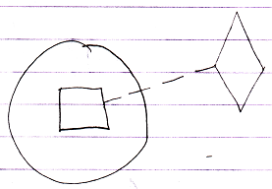

The access connectors:

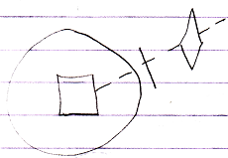

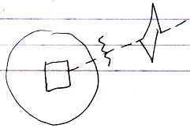

The problem with that is, that access controlling the Execute aspect is about the executability of the command object itself, not about the usability as a definition, and for the call to be executable.
Usability as a definition is expressed through access controlling Use As Class, anyway:

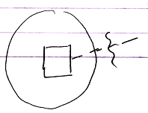

So that makes you able to access control being able to call a command, so basically to make a command Public or Private for calling. >

JJ

Other Details
Friends can always pass a reference to a private object
after all. Such 'betrayal' by friends is allowed. The friends are
the protectors. If they choose not to protect, than that's THEIR choice.
No problem.
> 2009-07-02 It’s a detail.

Fixed containment,

But it is friends that are supposed to be protectors?
And fixed containment, also makes the container a protector.
So are those friends as well?
The protected can only be accessed THROUGH the friend...
Hmmm... I have diagrams floating around in my head, but I can not hack it yet.
I can't see the class method (methods that are friends of the object)
as the protector, and the class itself as the protector of its the items it contains.

Gee... I just do not have it figured out yet.

JJ

Detail: mutual reference is required for a friendship to even work.

Consider the situation:
access to a selection of private members especially selected for the function.

Make an object befriended to a command.
Or befriend to a specific reference to a command.

If you can object-protect the data aspect and the parent applies exclusion to the data aspect, then you have it, that data is accessible on the inside, but not on the outside… do you all of a sudden have that literal inside-outside access control back then?

Details, May Not Cover

Access Modifier Get & Set
Interesting new system commands:
- Access Modifier Get
- Access Modifier Set
So would each system commands have its own system command
controlling the access modifier?
But what modifies the access to the access modifier system commands?
> Details...

Changing Access Modifiers at Run Time
Being able to change access modifiers at run time may be interesting. That way you can for instance change the interface of an object dependent on its settings. Changing a procedure’s access modifier is done by calling the procedure’s Access Modifier Set system procedure. There’s also an Access Modifier Get procedure to obtain the access modifier. This adds two system procedures to a square:

Access Modifier:
Get and Set

The Access Modifier property procedures can be access controlled themselves, so that they can be made inaccessible, for instance when you don’t want to be able to change the access modifier at run time. The access modifiers of the Access Modifier property can’t be changed at run time themselves. In other words: the Access Controller property procedures don’t have an Access Controller property of their own. This complies with the rule: system procedures don’t have system procedures of their own.

A single procedure can have several access modifiers so there are multiple access modifiers to get and set. This would suggest that the Accesss Modifier property has a dimension. However, when you call the Access Modifier property, you return or set the access modifier imposed by the object you’re calling from. The object you’re calling from is a hidden argument to the Access Modifier property. The access modifiers aren’t really stored inside the procedure, but in the object symbol that imposes it.

If the access modifier isn’t variable at run time, then the type defines a fixed access modifier. If the access modifier is variable at run time then the access modifier can be different for each instance of the type.

Changing ‘can be’ class, interface or object
System commands for changing access control to ‘can be’ class, interface or object.

Grouped Access Control
Using triangles to group members with equal acccess controllers. As with exclusion, the access controller of the triangle limits access again. It won’t make things more accessible.

Conditional Access Control
Replace the protected keyword by a concept like ‘when being a triangle’:
Basically you can optionally totally redefine the access for the case when the type is a used as a triangle.

<When being a globality?>

Or perhaps even make it as generall as ‘conditional access control’: Public if triangle.

Or perhaps I am looking too much for systematics behind it.

Perhaps the base of Use-As access control should (eventually) be based on conditional access control. But for now it can be limited to the conceptual explanation of the most usable things.

Delayed Creation of Object’s Privates
Public & Private,
2008-08-16

Perhaps for objects, private contents also only need to be created, when one of its friend commands is run.
>
But this is such an influential implication, that it needs to be covered elsewhere. Privates only make sense, when only a selection of commands, can access those privates.
So only when an object’s friend command is executed, the object’s private contents are needed.
But a sub-object’s system commands can also access privates…

JJ

Access Symbols And Accesses
< Just find an appropriate time to mention that each access symbol represents an access, but that it’s also used to denote direction, simply because direction can be read from it >

2009-06-28

It was realized too little, that each line crossing
is an access...

but in the automatic containment setting it is not.
The crossings of imaginary reference lines are not accesses.
The crossings of lines going from the imaginary reference to
the logical residence... I am not sure if those are active accesses.
They could be.
But this is more like an implementation detail....
Not important enough.

JJ

Maybe it's a good rule to only show access symbols to denote:

- Direction
- Exclusion of a procedure
- Denote explicitly the publicity

2009-06-28
- Each line that is crossed is a separate access.
That is probably why I wanted to have those extra ticks in expressing
access modifiers, but access modifiers and actual connections
are two different things. So the syntax of those two things is a different deal.
Whatever

JJ

Access Controller Parts
In one access controller you can use an exclusion access controller, an object level restriction and a globality level restriction:

- Protected Up 1 Globality Up 2

Access controllers as such are not usual, though and if you use them, they’re not very diverse.

> 2009-06-29: So basically this brainstorm item is about how an access controller can consist of different elements: each aspect is represented only once.

Uses of Access Controlling System Aspects
An object symbol’s Object Get procedure must be accessible to make you able to access its sub-object.

Exclusion of Set procedures controls who can set a symbol’s lines. Exclusion of Get procedures controls who can get information about lines or who can access the object.
> 2009-07-06: Or who can use the object as line source.

Other Details
< Give a story about the true meaning of an access symbol that denotes direction. That it is a syntactically correct access symbol. Access symbols can used to denote direction, because access symbols can point out direction.>

< A procedure’s primary access controller is only made Inaccessible to ‘outcomment’ code. This is a rather small concept. The rest of the use of Inaccessible and Accessible is in exclusion. Therefore, I need to denote in short that this is the only use of the primary access controller. I can basically always speak of access modifiers when talking about Accessible and Inaccessible. I can use the term exclusion in a lot of places where I now use ‘access control’. I also need to put the first section ‘Accessible and Inaccessible’ in the exclusion section. >

> 2009-06-26: I do not even know what I mean by this:
You will not be able to totally make clear what
private and friend means in this context,
but you can just use the term command anyway,
to make it clear.

< The word access modification can actually be replaced by ‘exclusion’ in many places, but not everywhere by far. >

Detail:
The symbols used here are actualy access symbols, which I’ve already introduced. Access symbols can denote direction, and they also denote where access takes place, but they’re also used to denote access control.

Interesting Applications of Exclusion
So examples of interesting applications of exclusion are:

- Making procedures Public or Private
- Excluding procedures of a public object
- Excluding procedures of a base object
- A parent’s controlling access to objects

Access to procedures is controlled. But access control usually defines which objects get access to them. In a special case you can control which specific procedures get access.

Out of Scope
Access Control,
2008-06-10

A user is also an object, that has private content,
that it can make public.

Every form of grant to access is given to an
object in the form of a virtual access card or ticket.
Tickets expire sooner than access cards.
The tickets and access cards form the access control
descriptor for what is accessible to an object.

An object describes what kind of options you have to
have on your card or ticket in order to get access.

Objects have their own security relations.
A user-object is an object with
certain access, but sees the objects' restrictions
to eachother. What's that about? How does that work?

JJ

Commands,
2008-05-18

In the diagrams of Relations Between Commands & Objects you can see, that a call to a command can be a call upon multiple objects to execute that command. It is not yet discussed, how it is expressed that a command has access to the private contents of a class.

JJ

Obsolete

About Exclusion
< A way to show access modifiers for deeper depths than 1 so access modifiers other than accessible, inaccessible, public or private >

Exclusion is the primary method for controlling which parties get access to a procedure.

A class controls which of its procedures are accessible to the outside (Public procedures), and which are not accessible to the outside (Private procedures). Private procedures are accessible to the inside the type.

> 2009-06-27: But only by commands that are friends of the object, which do not even have to be inside the object…

About Diagram Notation of Exclusion

Public and Private are notated as follows:

  Public |   Private

The reason that the following notation won’t do:

  Not Public |   Not Private

is that this access modifier is imposed by the procedure itself, not by its parent.

The reason that the following notation won’t do:

  Not Public |   Not Private

is that the access symbols in these diagrams are about access to the object, not access to the procedure of the object.

Each descendant that has access to the procedure can impose its own access modifier upon it.

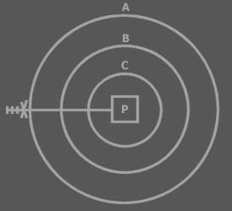

In this example A privatises P. The marks and the access controller are called an access controller list. The whole access controller list can be interpreted as a single symbol, which can be called the access symbol. An access controller can be placed on each mark. Each position in the access controller list represents the access modification of a deeper laid symbol. All access modifications are imposed by A. The first position modifies access to A itself,

> 2009-06-27: Actually, when you modify access to A itself, you should just create another line, attachted to A and access control it. Those extra ticks are not required at all.
> The extra ticks in exclusion access controllers in the Symbol documentation are not required, because the line itself suggests what is pointed at... The placement of the access controller does say something about which container access controls it.

the second position modifies access to B, the third position modifies access to C, thus the fourth position modifies access to P. The marks are called access marks, not to be confused with the term ‘access symbols’.

Very deep exclusion is uncommon, so you usually won’t interprent more than one or two access marks.

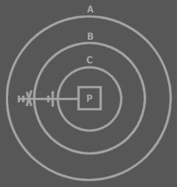

Privatisation is the last access modification. Once an descendant has excluded the member, higher descendants can’t exclude the member again, because they can’t access the member.

B has excluded P, so A can’t exclude P again. Both access symbols above are about access to P. The first position of the access controller list is always about access to the symbol that defines the access controller list. Not all positions of the access controller need to be displayed. The last positions can be left out at will. That means that the last access controller doesn’t have to be about the line target, but can be about an intermediate access.

Let’s cover how to interpret the examples I’ve already mentioned.

With these access modifiers, the procedure is making itself accessible or inaccessible.

With these access modifiers, the object is making itself accessible or inaccessible.
> 2009-06-27 And that is what I disagree with now. If the object was to make itself inaccessible, then the line should have ended at the object, not at the procedure.

This shows the access symbol for Public. The object is making the procedure accessible to the outside.

This shows the access symbol for Private. The object is making the procedure inaccessible to the outside. The procedure is accessible inside the object. You could denote this:



The extra access symbol denotes that the procedure makes itself accessible.
> 2009-06-27: I would give that its own line now…
The access symbol of the object makes the procedure inaccessible to the outside. Procedures are usually accessible to the object symbol they are directly contained in, so the extra access symbol is not really required.

> 2009-06-27: < start of useless story to tell >

A parent can’t make a child’s procedure inaccessible to the parent. The effect of this rejected concept is basically identical to giving the child its own abstract type: a derived type that excludes members of its base:

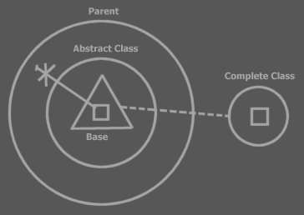

The parent contains a child object. The type of the child is defined right inside the parent: Abstract Type. The type is based on the complete type. The abstract type simply excludes a few members. You don’t always need to show the excluded members. In some views you will only see the published members:

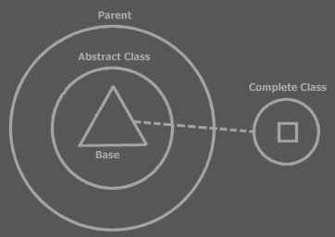

> 2009-06-27: < end of useless story to tell >

A Procedure’s Set of Access Controllers

> 2009-06-27: < start of another useless story to tell >

Exclusion adds a whole set of access modifiers to a single procedure.

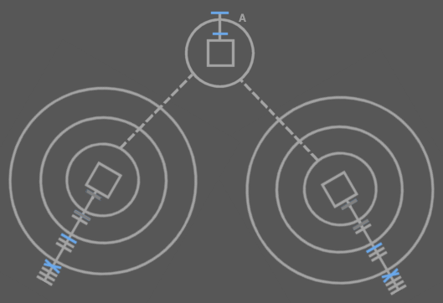

The access symbols in blue are the procedure’s access controllers. The dark grey access symbols are also the procedure’s access controllers, but these were already defined in type A. You can see that in any other type that uses an object of type A, a new set of access modifiers can be imposed. You see that each access controller of the single procedure is shown at a different symbol. The access modifier for a procedure is shown close to the type that imposes the modifier.

> 2009-06-27: < end of another useless story to tell >

Constants (Brainstorm)
<oops the following text can not be put in the introduction>

Design Time Set and Design Time Copy are actually called at run time, because nothing is set at design time. Design Time Set, though, can only be called in the Create procedure of the closest mutual descendant. Actually, a set in the create procedure is actually a call to the Design Time Set and Design Time Copy.

The initialization of constants happens in the Create procedure of the mutual descendant. < <OR THE one that defines that the set is only for design time?> Explaining that would require knowledge of exclusion.>

Other
Only types can be befriended. Friends can be both types and separate procedures.
> 2009-06-28: This is not required in the new setting. A command can also be befriended, making its privates accessible, but I am not sure how useful that will be, though, or even possible when privates of commands have delayed creation.

< So you can choose to give friends access to all private members or, another method, which requires a different syntax, allows you to make a selection of private things public to friends. >
> 2009-06-29: Obsolete, because that was the friend method concept, which is replaced by befriending an object with a command object.

Er moet access control zijn voor het stellen van lines, bijvoorbeeld naar de inhoud van een parent.

- Inside directly accessible, outside only 'indirectly' accessible (if line set FOR you)

Little disclaimer: I use the word Friend here, but it’s not the same as the Friend access controller. It’s a keyword overused here. However, it’s overused the same way in C++ and I have not yet come up with a decent alternative. The word Friend has been taken over from C++, just like the other access controller keywords. The access controller keywords aren’t super accurate description of their effect, they are just picked because the words are short and you can related their meaning remotely to their effect. I ain’t good at coming up with inaccurate names for something, so I can’t find an alternative now for this second hand use of the keyword Friend. I could go look for more concise words for the access controllers, but those would confuse me, because I’m still used to the old words. And it’s hard enough trying to get the description of this programming language on paper as it is.

Continguous dissector < | Friend for reference

Do Not Use
< Don’t say that procedures can’t be defined as inaccessible. They have to be definable as inaccessible or you’re not able to ‘comment out’ code. This also requires you to use the term access controllers more often. >

> 2009-06-28: don’t even mention this in the future. It is so trivial:

A line other than a call line can show access symbols, while there aren't really any access. These access symbols represent accesses made by the mutual descendant when it set the line. Accesses did occur on calls to the Set and Copy procedures of the source and target symbols when the line was set.

Access symbols are also used in a diagram only to indicate the access control. In that case there’s no question of an access either. Only of an access that might or might not occur.

<< … yes this is a section >>

Darn. What if you want to group members that are excluded. Then the parent adds a grouping to the child type. Oops this grouping is not part of the child type. Well.. it can’t be used then.

I can use this notation:



So Symbol…
Has put all of the language’s access controllers in one system and added extra useful systematics.

Automatic Changes when Editing Code
When you for instance use triangles to group members of an object, then the access modifiers need to change. When first you accessed something one capsule deep, is accessed two capsules deep when you put a triangle or circle around it. Access modifiers change accordingly when you edit code:

<P: Circle with public procedure >
<P: Trangle put around public procedure, changed access modifier>
<P: Circle with public procedure >
<P: Circle put around public procedure, changed access modifier>

You can’t always just put circles and triangles around everything. You might have to adjust access controllers, which are explained later. <Is that so?>

> First of all, in the newer notation, that does not have those access ticks, you do not really see the difference. Second of all, this is a detail, that will work itself out.

Other
Oh, optional parameters are initialized and then assigned the caller’s value. Where are those two steps performed.

Procedure primarily Inaccessible: This seems unuseful: why not just leave the procedure out completely? It could be used a means to temporarily deactivate code.

Private & Public,
2008-06-10

Do not use:

Next to public, private and who has access to it,
who can access the public and private contents.

If you have friend access to private contents,
you see it as though it was public contents.
> 2009-06-26: No: accessible contents.

JJ

Postponed
< Any abstract meaning of a symbol could be used in abstract diagram notation. To express something but not even totally syntactically correct. So in abstract symbol you also have syntactically correct abstract diagram notation, but also syntactically incorrect abstract diagram notation. >

